Q1) Fill in the table below. Compile sample program with no optimization, then optimization levels of 1, 2 and 3. Then enter the output in output column.

|  | Output (Real time) |
| --- | --- |
| sample-nonopt | 0m2.864s |
| OPT=1 sample-opt | 0m0.001s |
| OPT=2 sample-opt | 0m0.001s |
| OPT=3 sample-opt | 0m0.001s |

Q2) **What function in sample-gprof-nonopt takes the most time (except main function, just give the name of the function)?**

make sample-gprof-nonopt

./sample-gprof-nonopt

100 304 506 6078 0

gprof sample-gprof-nonopt | more

The percent time is more for make_nonempty whereas insert_list took more cumulative seconds.

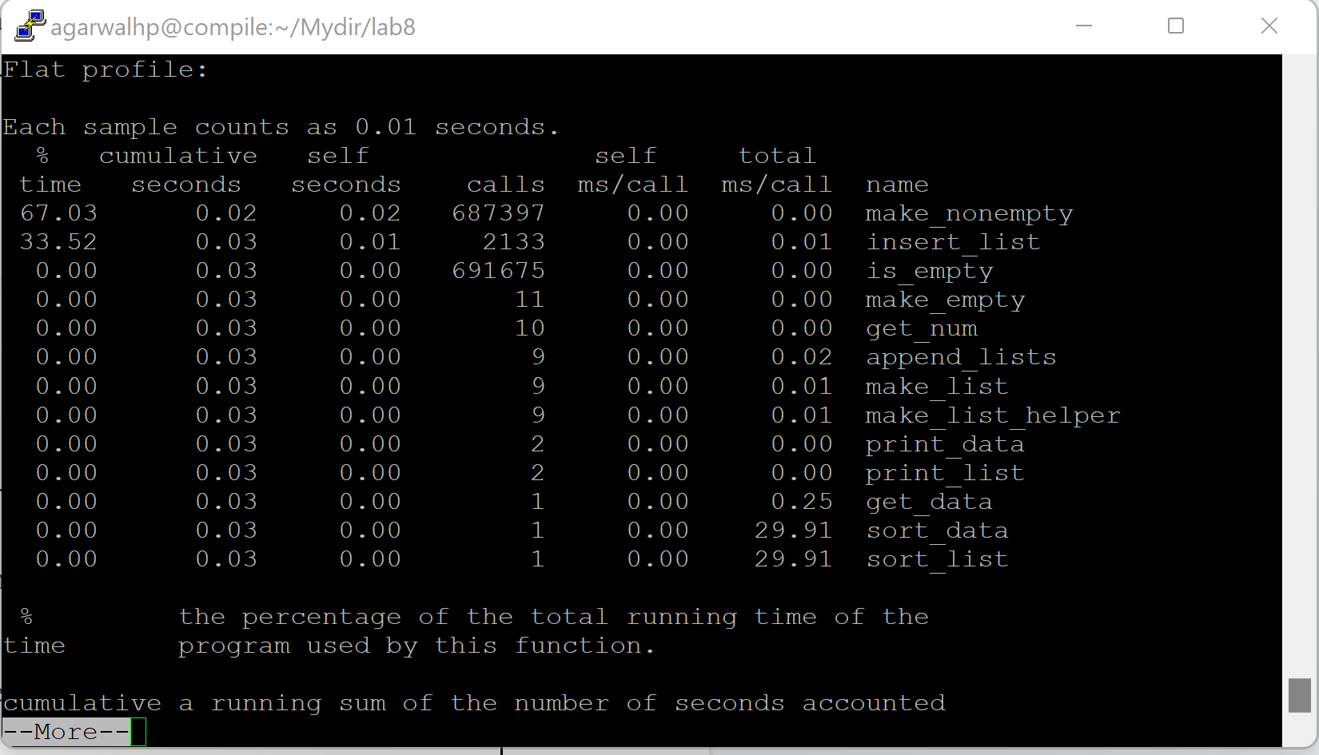

Q3) **What statement is executed the most times (just the piece of code that is executed the most) ?**

is_empty executed the most times.

